Smartfarmer - IoT Enabled Smart

Farming Application -SOLUTION ARCHITECTURE



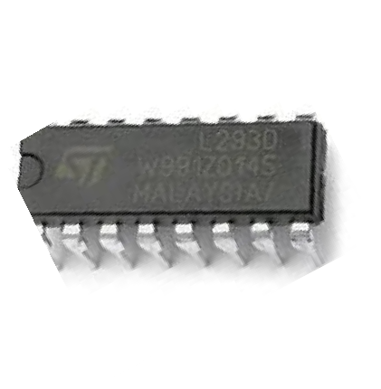

**OPEN WEATHER API**



**TEMPERATURE AND HUMIDITY SENSOR**

**L293D (16 PIN IC )**

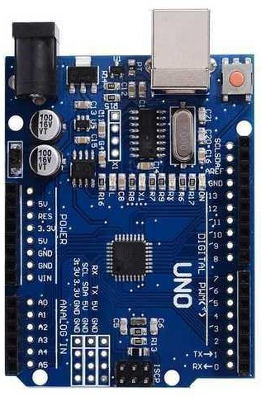

**ARDUINO-UNO**

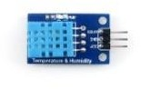

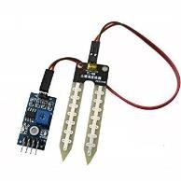**SOIL MOISTURE SENSOR**

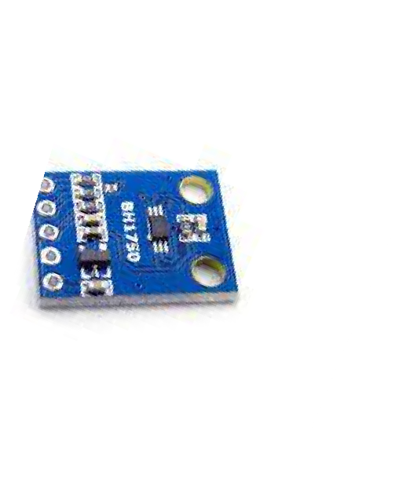

**LIGHT INTENSITY SENSOR**

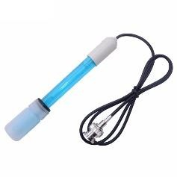

**pH SENSOR**

**IBM IoT CLOUD**

**MOBILE APP**

* The different soil parameters (temperature, humidity, light intensity, pH level) are sensed using different sensors and the obtained value is stored in IBM cloud.
* Arduino uno is used as a processing unit which processes the data obtained from sensors and weather data from weather API.
* Node red is used as a programming tool to wire the hardware, software and APIs. The MQTT protocol is followed for communication.
* All the collected data are provided to the user through a mobile application which was developed using MIT app inventor. The user could make decision through an app, whether to water the crop or not depending upon the sensor values.